# INTRODUCTION:

1 .1OVERVIEW

Economic freedom is the fundamental right of every human to control his or her own labour and property. In an economically free society, individuals are free to work, produce, consume, and invest in any way they please. In economically free societies, governments allow labour, capital, and goods to move freely, and refrain from coercion or constraint of liberty beyond the extent necessary to protect and maintain liberty itself. For much of human history, most individuals have lacked economic freedom and opportunity, condemning them to poverty and deprivation. Today, we live in the most prosperous time in human history. Poverty, sicknesses, and ignorance are receding throughout the world, due in large part to the advance of economic freedom. In 2022, the principles of economic freedom that have fuel this monumental progress are once again measured in the Index of Economic Freedom, an annual guide published by The Heritage Foundation, Washington's No. 1 think tank.

1.2 PURPOSE

We measure economic freedom based on 12 quantitative and qualitative factors, grouped into four broad categories, or pillars, of economic freedom:

1) Rule of law property rights, government integrity, judicial effectiveness)

2) Government size (government spending, tax burden, fiscal health)

3) Regulatory efficiency (business freedom, labour freedom, monetary freedom)

4) Open markets (trade freedom, investment freedom, financial freedom)

● Define Problem / Problem Understanding

o Specify the business problem

o Business requirements

o Literature Survey

o Social or Business Impact.

● Data Collection & Extraction from Database

o Collect the dataset,

o Storing Data in DB

o Perform SQL Operations

o Connect DB with Tableau

● Data Preparation

o Prepare the Data for Visualization

● Data Visualizations

o No of Unique Visualizations

● Dashboard

o Responsive and Design of Dashboard

● Story

o No of Scenes of Story

2 PROBLEM DEFINITION & DESIGN THINKING:

2.1EMPATHY MAP

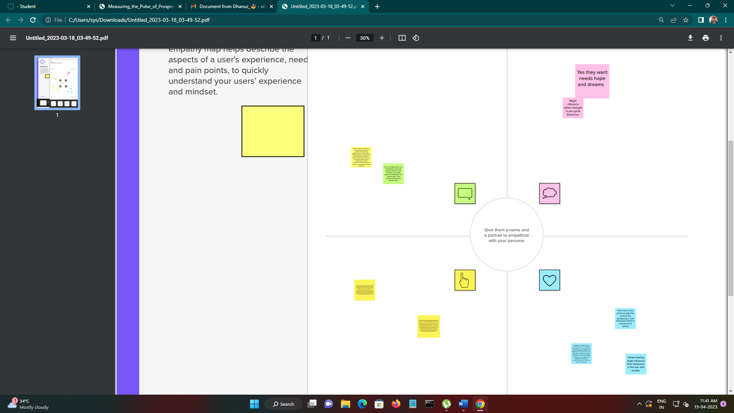

2.2IDENTATION & BRAINSTROMING MAP

SCREENSHOT

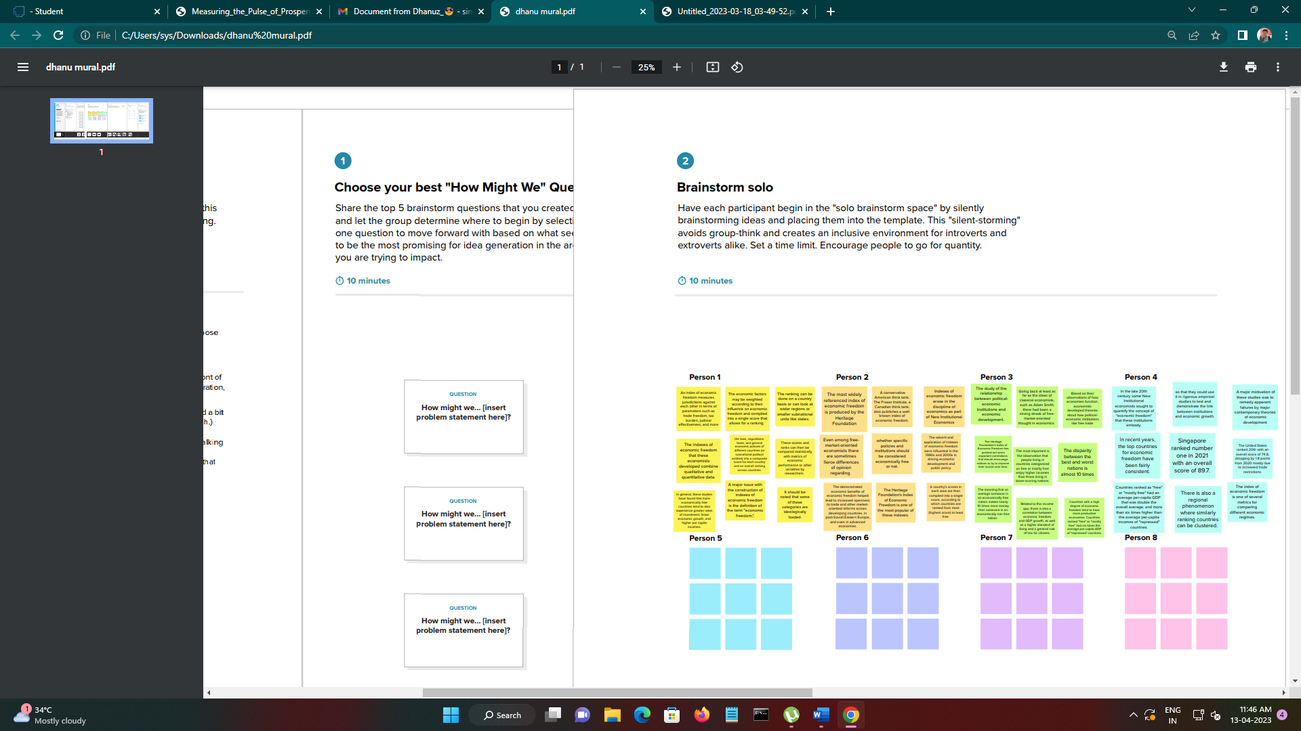

3 RESULT

DASHBOARD 1

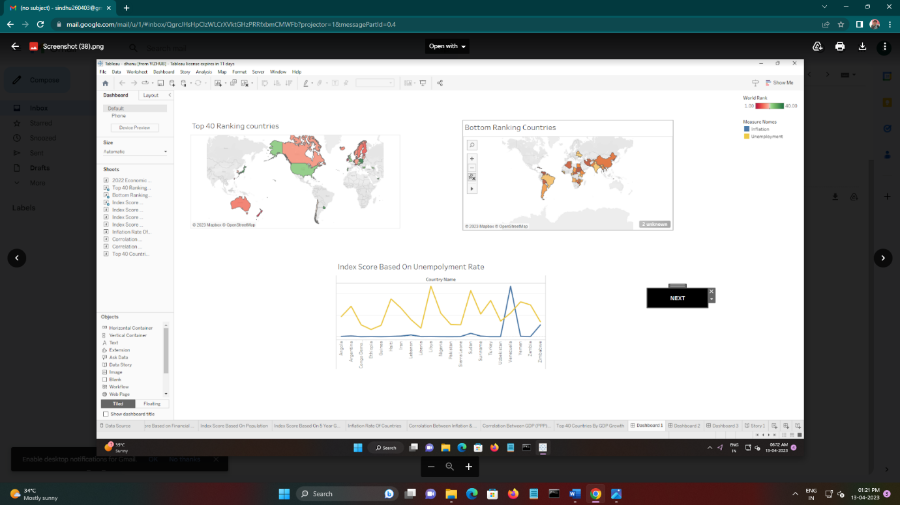

Dashboard 2

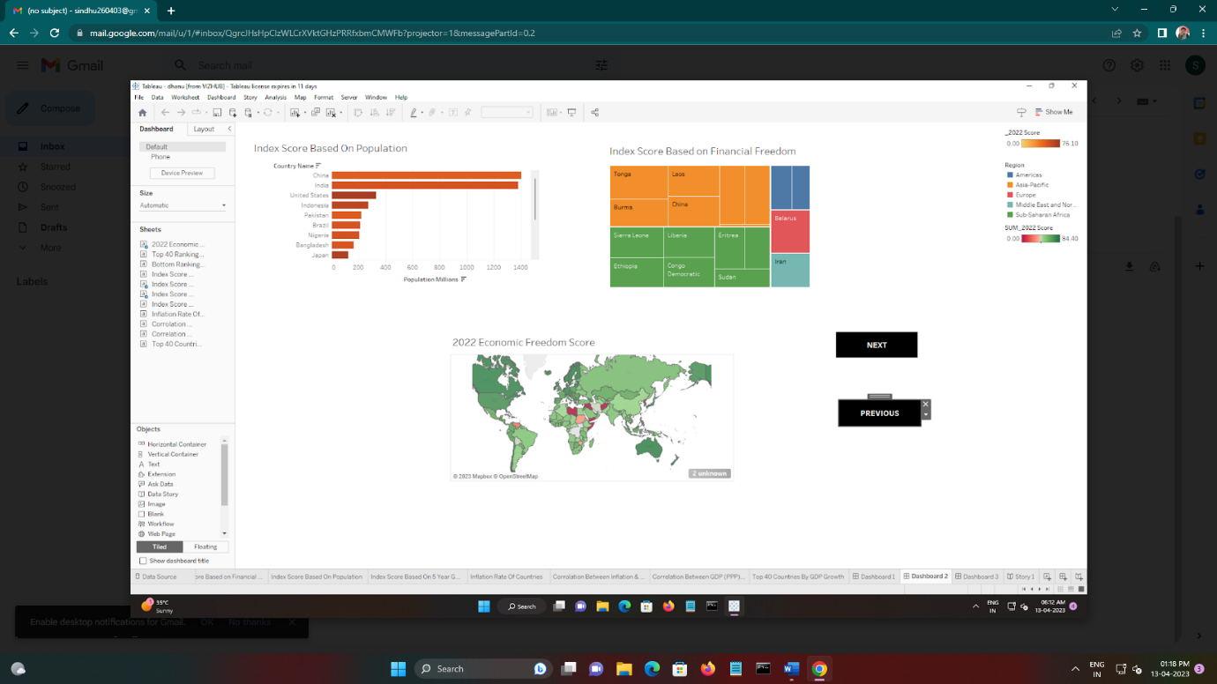

Dashboard 3

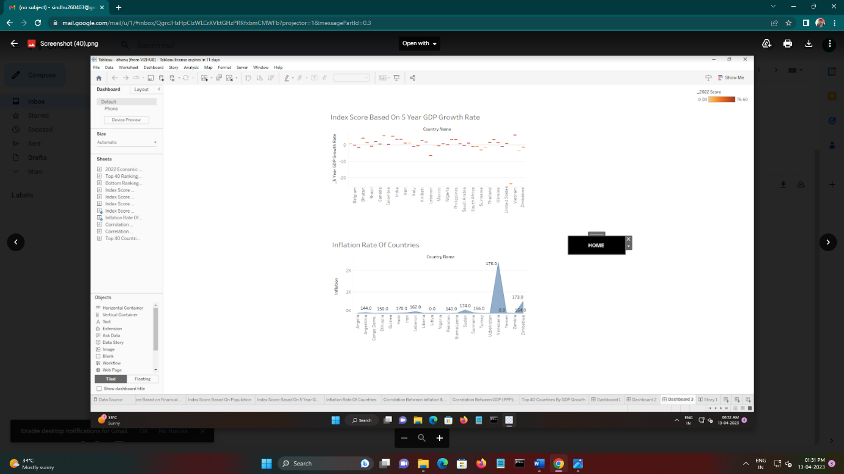

Story 1

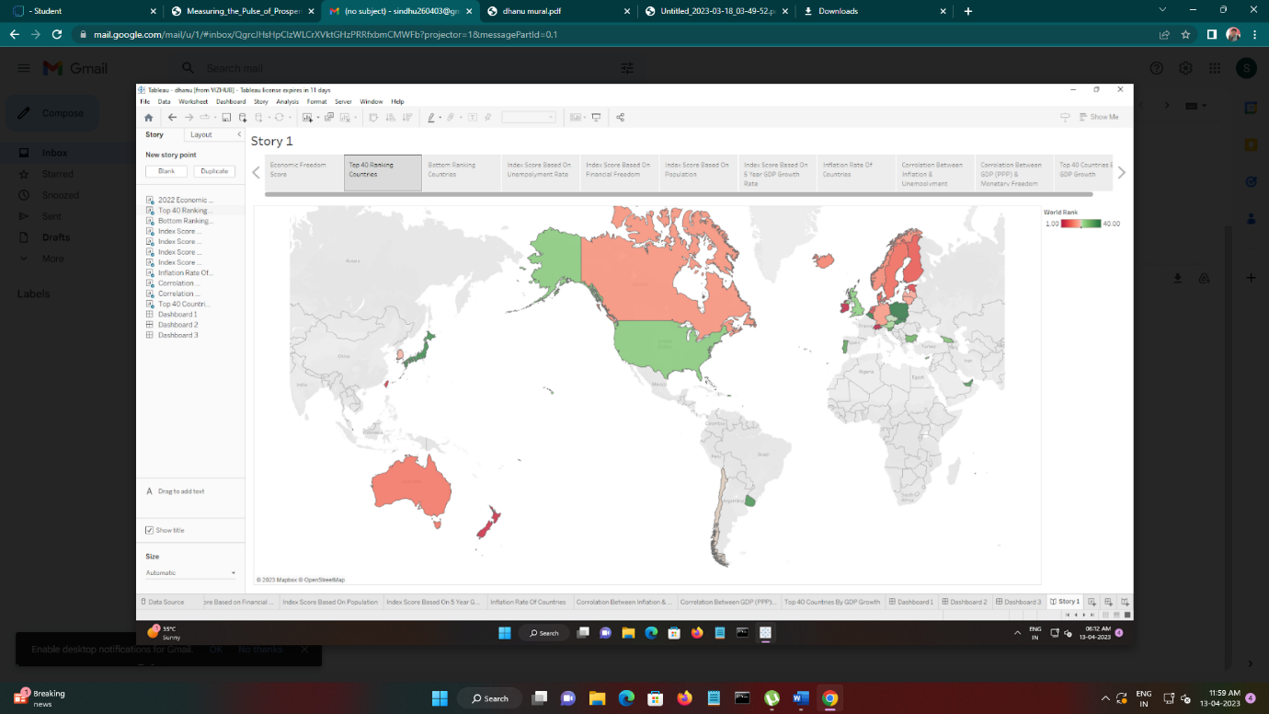

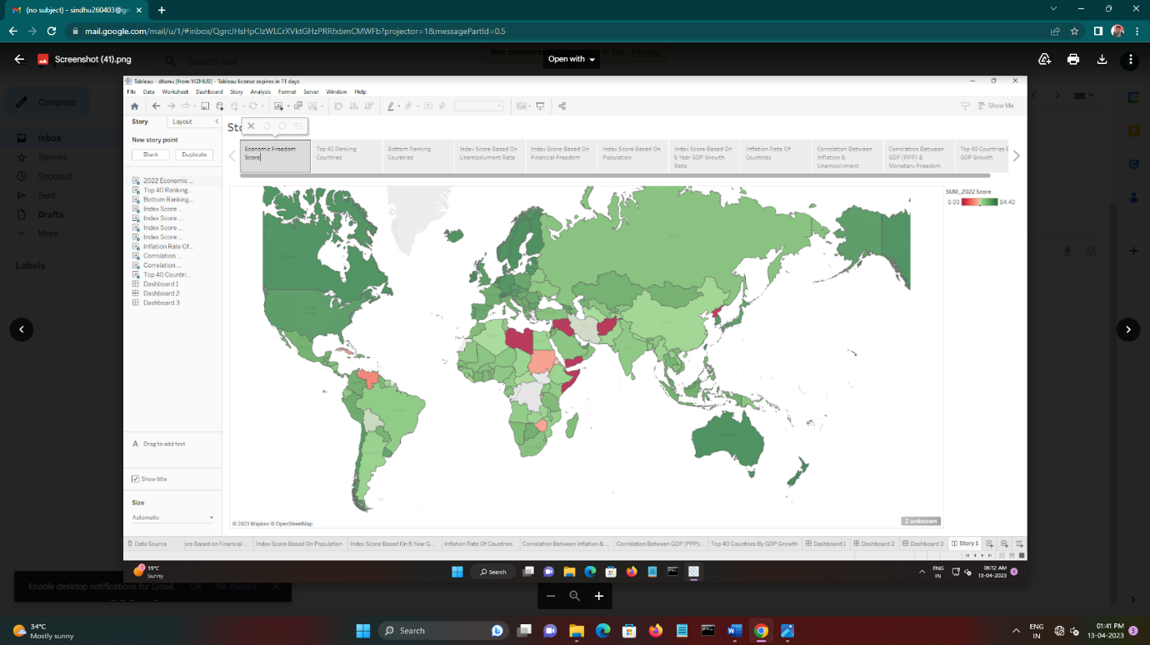

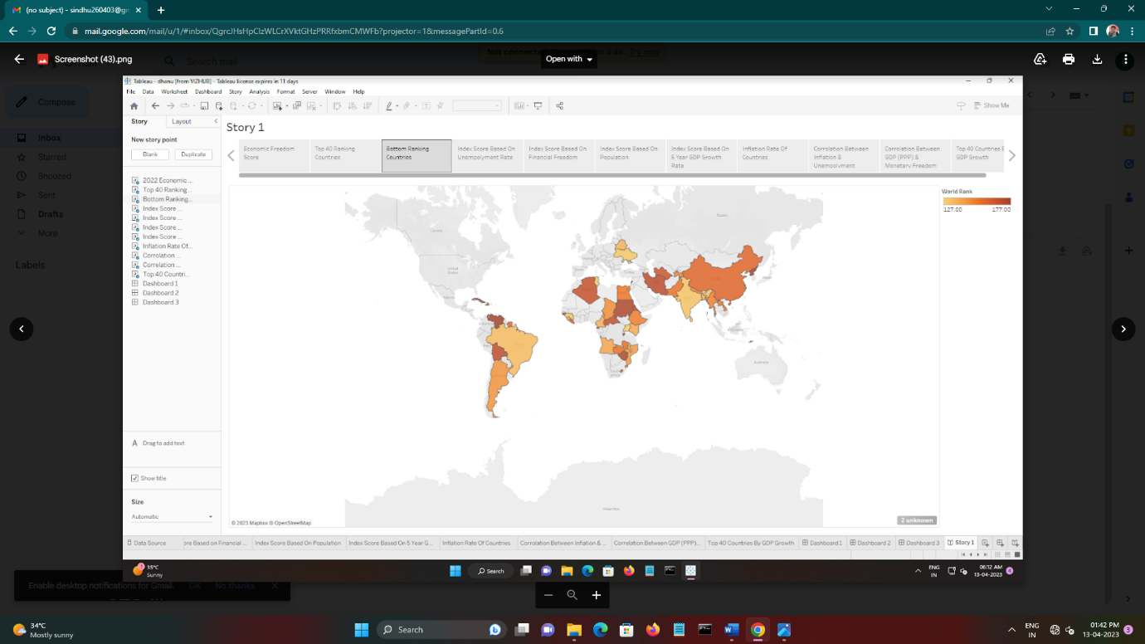

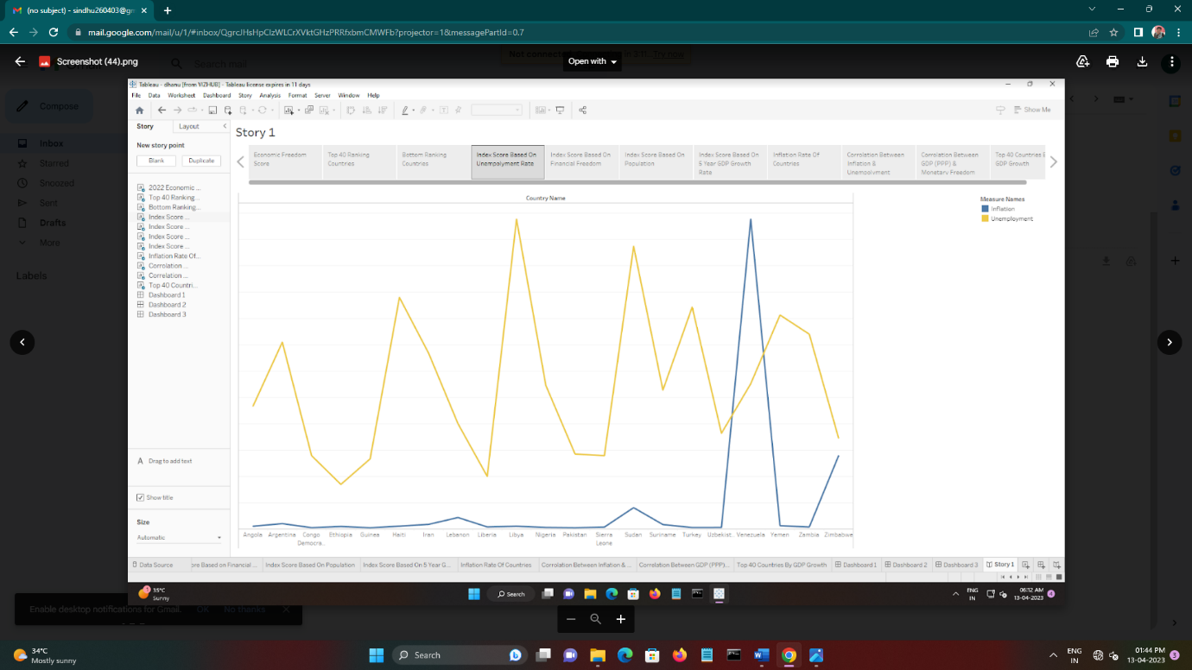

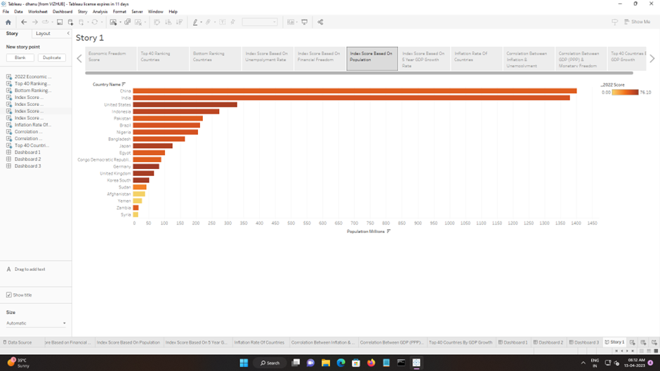

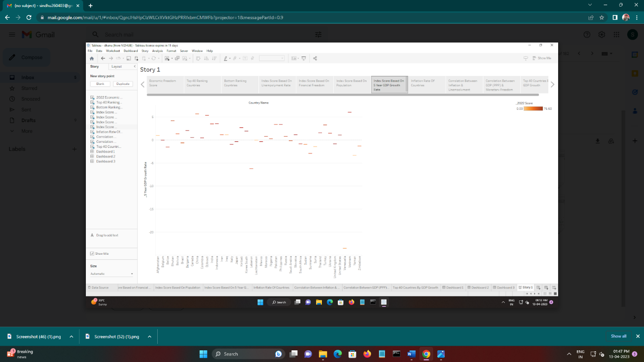

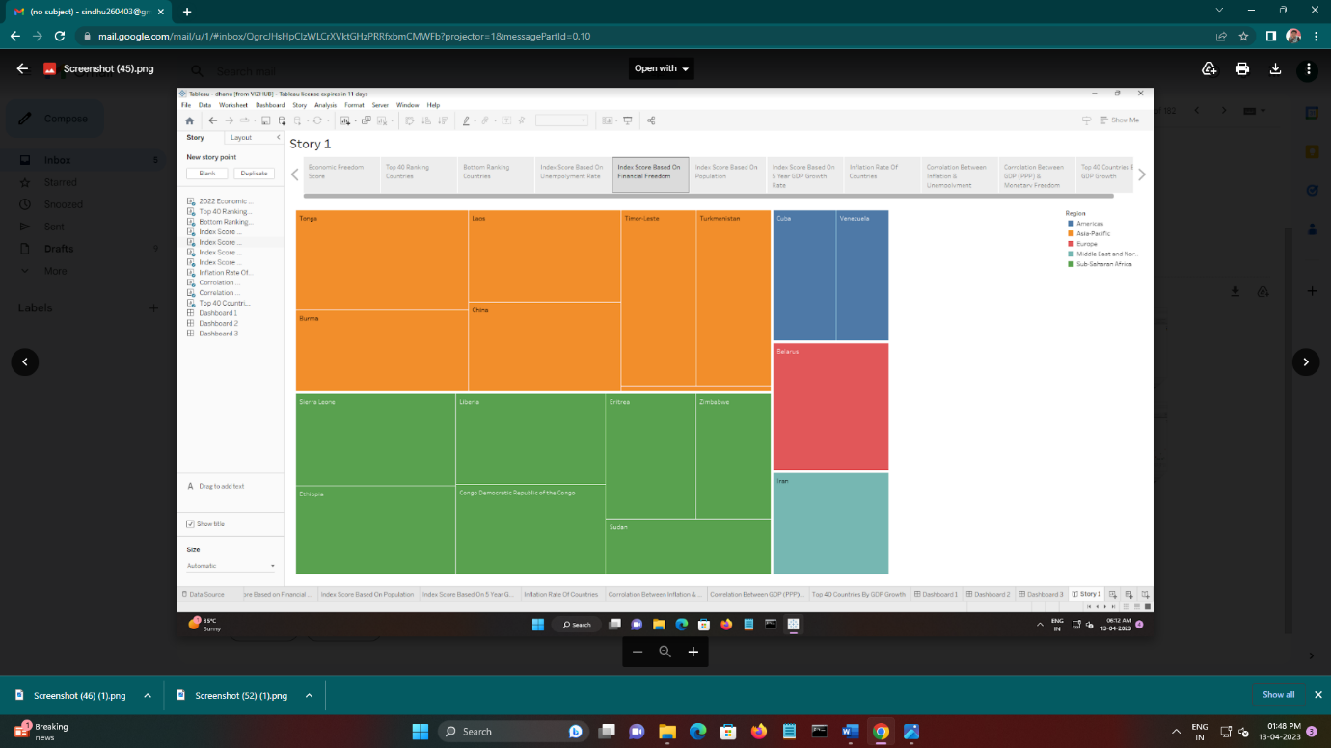

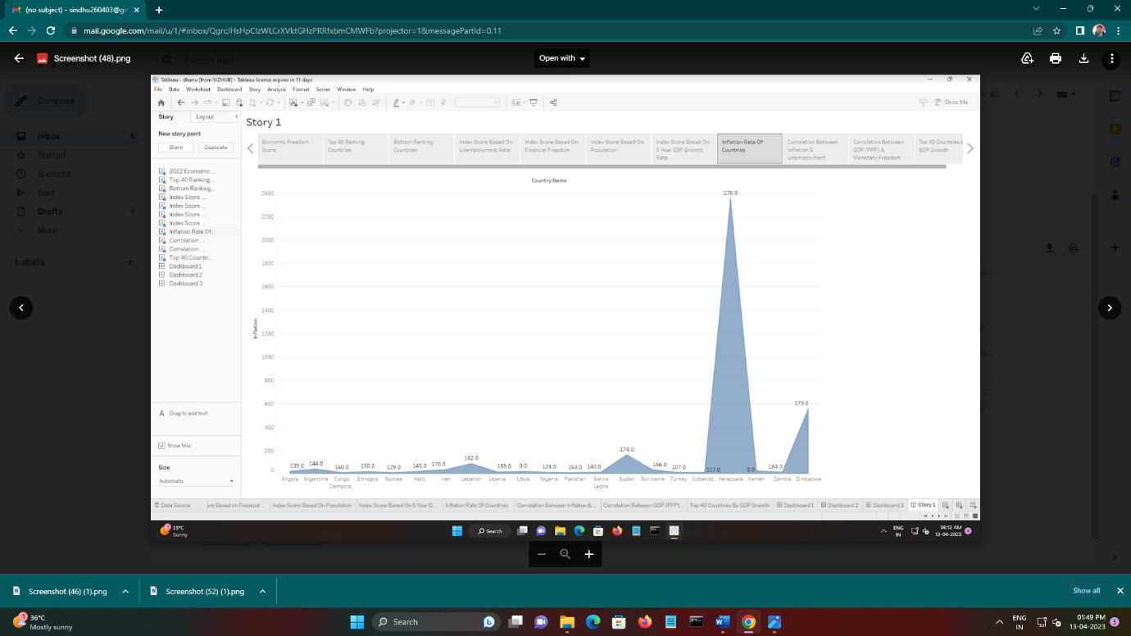

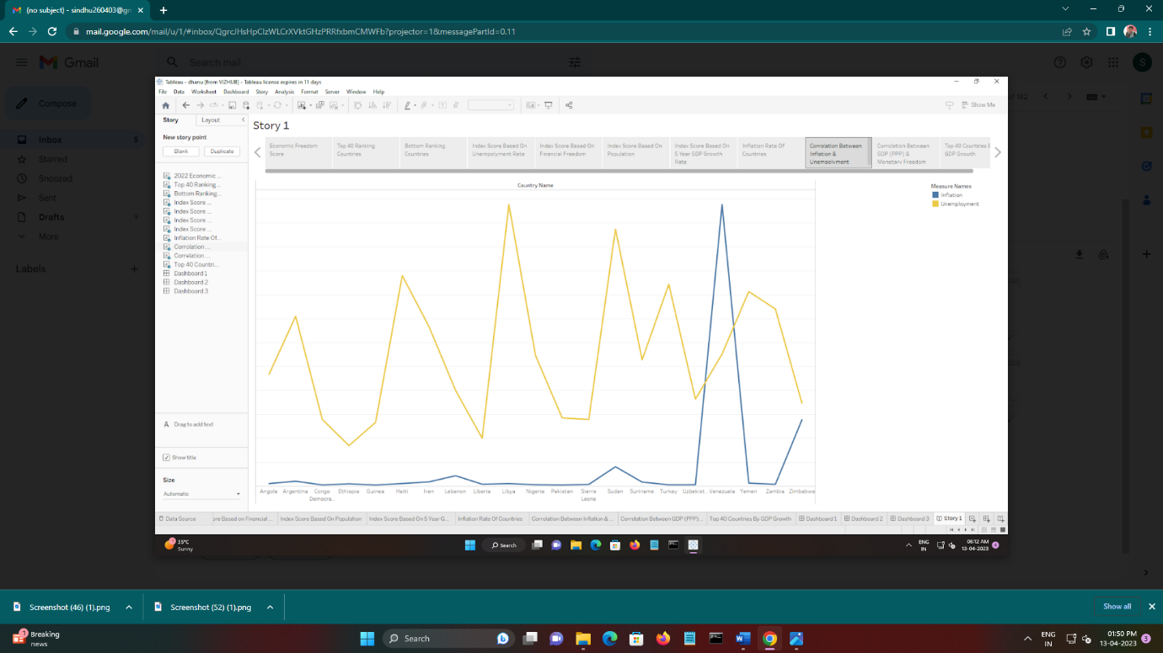

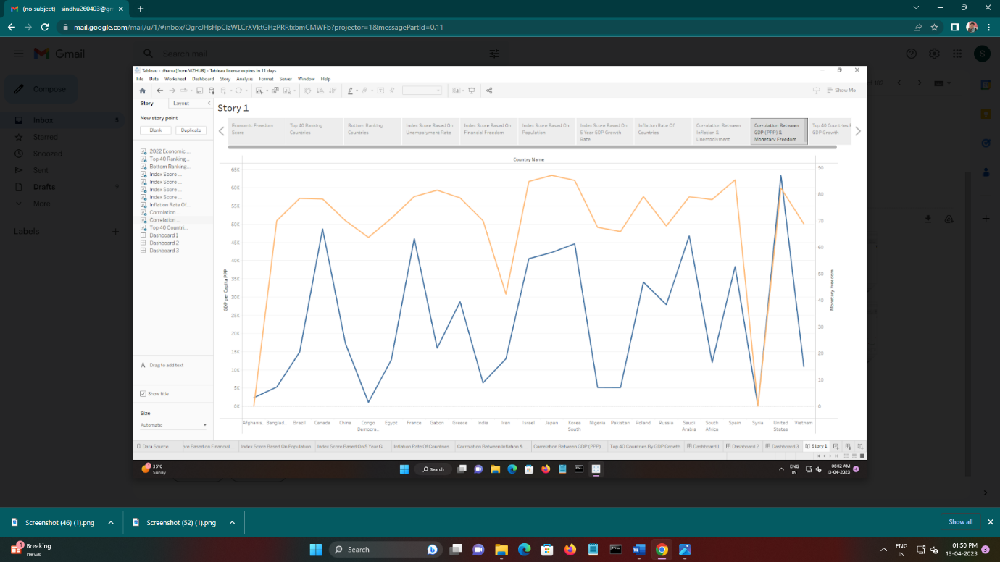

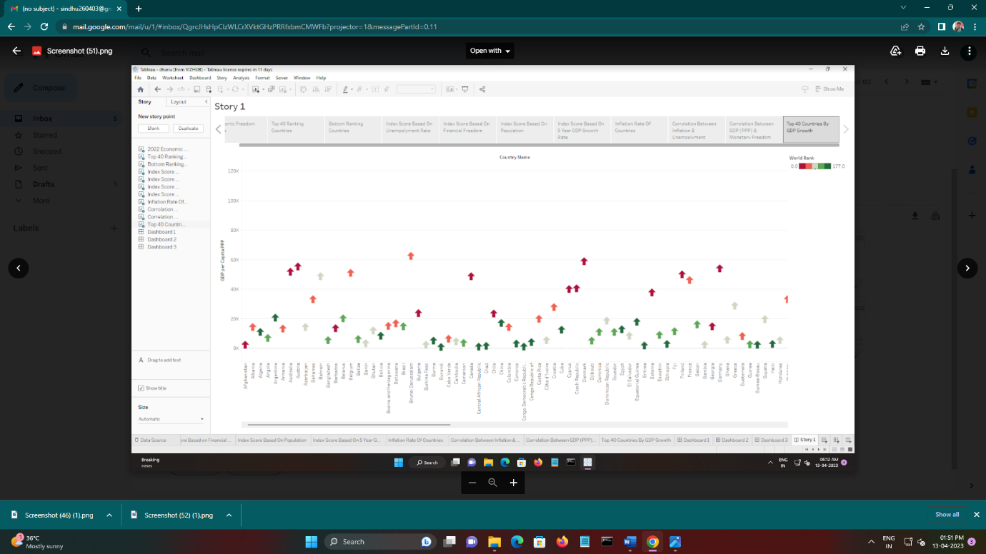

4 ADVANTAGES & DISADVANTAGES

* Economic growth is a matter of good institutions (including economic freedom), not a matter of natural resource Hong Kong, a semi-independent territory of the United Kingdom until 1997, provides a good example.
* The Economic Freedom of the World (EFW) index, compiled by the Fraser Institute since 1970, has generally ranked the tiny, resource-poor country as the economically freest country in the world.
* The most obvious benefit of economic freedom is that, as a system, it is the most conducive to widespread prosperity, that is, to high or rising income and consumption for the bulk of the population.
* Another telling example of the benefits of economic freedom is provided by the two Koreas, which shared the same culture and were at roughly the same level of development when they separated in 1948.
* The index combined with World Bank data on economic growth suggest that more economic freedom over the past 25 years is associated with higher incomes today.
* There is voluntary production and consumption of goods, with overall freedom for every individual to make their own choices
* Overwhelmingly, there is private ownership and control of and property, including the means of production as well as the labour supply
* Self-interest is the primary motivator for all economic decisions

5 APPLICATION

* MEASURING PULSE OF ECONOMIC FREEDOM:
* In economically free societies, governments allow labour, capital, and goods to move freely, and refrain from coercion or constraint of liberty beyond the extent necessary to protect and maintain liberty itself."By publishing yearly reports the foundation attempts to highlight where such freedoms do and don't exist.
* According to the Cato Institute, higher economic freedom promotes participation and collaboration. Also claimed is that higher economic freedom is extremely significant in preventing wars; according to their calculations, freedom is around 54 times more effective than democracy (as measured by *Democracy Score*) in diminishing violent conflict.
* In 2011, the United States dropped to 9th place behind such countries as Denmark, Canada, and first-place Hong Kong. The Heritage Foundation has pointed to increases in government spending as the reason for the United States' decline, and according to data from the 2011 index, the growth rates of countries with the highest levels of government spending were 4.5 points lower, on average, than countries where government spending was under control. In their "Executive Highlights" of index results, the Heritage Foundation stated that "high levels of government spending in response to the global economic turmoil have not resulted in higher economic growth".
* The [UAE](https://en.wikipedia.org/wiki/UAE) questioned the rating of their country's economic freedom in 2008, comparing its middling rating with the high rating they had received from other indicators such as [Transparency International](https://en.wikipedia.org/wiki/Transparency_International) and [Moody's](https://en.wikipedia.org/wiki/Moody%27s). They also argued that the report is "unreliable", because its methodology had changed twice in the last two years.
* The index scores nations on ten factors of economic freedom, separated into four categories, using statistics from organizations like the [World Bank](https://en.wikipedia.org/wiki/World_Bank), the [International Monetary Fund](https://en.wikipedia.org/wiki/International_Monetary_Fund), [Economist Intelligence Unit](https://en.wikipedia.org/wiki/Economist_Intelligence_Unit) and [Transparency International](https://en.wikipedia.org/wiki/Transparency_International). In each factor, countries are scored 0 to 100, with 0 being the least free and 100 the most free. A score of 100 signifies an economic environment or set of policies that is most conducive to economic freedom. The methodology has shifted and changed as new data and measurements have become available, especially in the area of Labour Freedom, which was given its own indicator spot in 2007. The following list explains what each factor currently assesses and groups them according to their respective category.

6 CONCLUTION

* A literature survey for a project on "Measuring the Pulse of Prosperity:
* An Index of Economic Freedom Analysis" would involve researching and reviewing existing studies and literature on economic freedom and its impact on prosperity.
* This could include looking at different indexes and measurements of economic freedom, as well as studying the correlation between economic freedom and measures of prosperity such as GDP growth, income inequality, and quality of life indicators.
* The literature survey may also examine the ways in which economic freedom can be promoted and sustained, as well as any potential challenges or criticisms of the concept of economic freedom.
* It would also be important to review any case studies or real world examples of the impact of economic freedom on prosperity.

7 FUTURE SCOPE

* Social Impact: A high level of economic freedom is usually associated with higher standards of living, more opportunities for individuals to improve their economic status, and greater access to goods and services.
* Business Model/Impact: a high level of economic freedom would likely indicate a more favourable business environment.
* Data collection is the process of gathering and measuring information on variables of interest, in an established systematic fashion that enables one to answer stated research questions, test hypotheses, and evaluate outcomes and generate insights from the data.

8 APPENDIX

1. SOURCE CODE